B.P.H.E Society Ahmednagar
College Ahmednagar

SYBBA(CA) SEMESTER IV
SUBJECT: - PROJECT EVALUATION SHEET COURSE

Project Name-
INVENTORY MANAGEMENT SYSTEM
NAME OF STUDENT: -
1: RITU BHRADWAJ 2: ANJALI SHINDE
ROLL NO: - 20 ,124
TEACHER NAME: -
Tahrim Ma’am


Department Computer Science
CERTIFICATE
This is to certify that the project,
Inventory Management System
Has been completed successfully by-
Ritu Bhardwaj, Anjali Shinde
For the practical fulfilment of Department of computer Science as laid down by the Pune University during Academic Year 2025

Head of Department Project in charge
Internal Examiner’s External Examiner’s

Place: Ahmednagar Date:

Inventory Management System

Acknowledgement

We wish to take opportunity to express our profound thanks and gratitude to all those who have directly or indirectly helped us in the completion of the project.

The project titled "Inventory Management System" would not have been completed without the valuable guidance and encouragement of Mrs. Madhavi Dethe Ma'am for giving us the constant source of inspiration. We are extremely thankful to Prof. Mr. Sayyad Razak Sir, A head of the department and all my faculty members for their guidance and moral support.

INVENTORY MANAGEMENT SYSTEM
INDEX
Sr.No | Chapter | Page No
1 | Chapter 1. Introduction  1.1 Objective of the Project  1.2 Existing System  1.3 Proposed System
2 | Chapter 2. Requirement Analysis  2.1 Feasibility Study  2.2 Fact Finding Techniques  2.3 Project Requirements
3 | Chapter 3. System Design  3.1 E-R Diagram  3.2 Data Flow Diagram
4 | Chapter 4. Data Dictionary
5 | Chapter 5. Screens  5.1 Input Screens  5.2 Output Screens
6 | Chapter 6. Testing  *Test Steps, Data Validation Test Cases, and Results
7 | Chapter 7. Limitations and Future Enhancements
8 | Chapter 8. Bibliography
INTRODUCTION
1.1 Objective
The goal of the Inventory Management System is to help businesses keep a better track of their inventory in a more organized and efficient way. This system makes it easier to maintain accurate records of products, suppliers, and customers. By using it, businesses can optimize their stock levels, cut down on waste, and boost their overall operational efficiency.
Existing System : The current inventory management system typically depends on manual record-keeping through paper logs or spreadsheets. This method can result in inefficiencies, mistakes, and slower decision-making processes.
1.3 Proposed System
In our project, we’ve developed a web-based Inventory Management System that aims to simplify the management of product tracking, customer records, and transportation details. Here are some of its key features:
* User Registration and Authentication
* Product Management
* Customer Management
* Transportation Tracking
* Reports and Analytics

REQUIREMENT ANALYSIS
2.1 Feasibility Study
Technical Feasibility
This system uses HTML, CSS, and JavaScript for the front end and can easily connect with a backend database like .
Economic Feasibility
Implementing this system can cut down on the costs associated with manual record-keeping and help prevent inventory losses, making it a financially smart choice.
Operational Feasibility
The system is user-friendly and only requires basic computer skills, so it’s practical for both employees and business owners to operate effectively.
2.2 Fact Finding Techniques
- Observation: Studied manual inventory management processes.
- Record Review: Analyzed inventory records from businesses.
2.3 Project Requirements
Hardware Requirements
- Processor: Intel Pentium or higher
- RAM: 8GB or more
- Storage: 100MB or more
Software Requirements
- Operating System: Windows 10 or above
- Browser: Mozilla Firefox, Google Chrome, Microsoft Edge
- Web Technologies: HTML, CSS, JavaScript
SYSTEM DESIGN
3.1 Entity-Relationship Diagram (E-R Diagram)
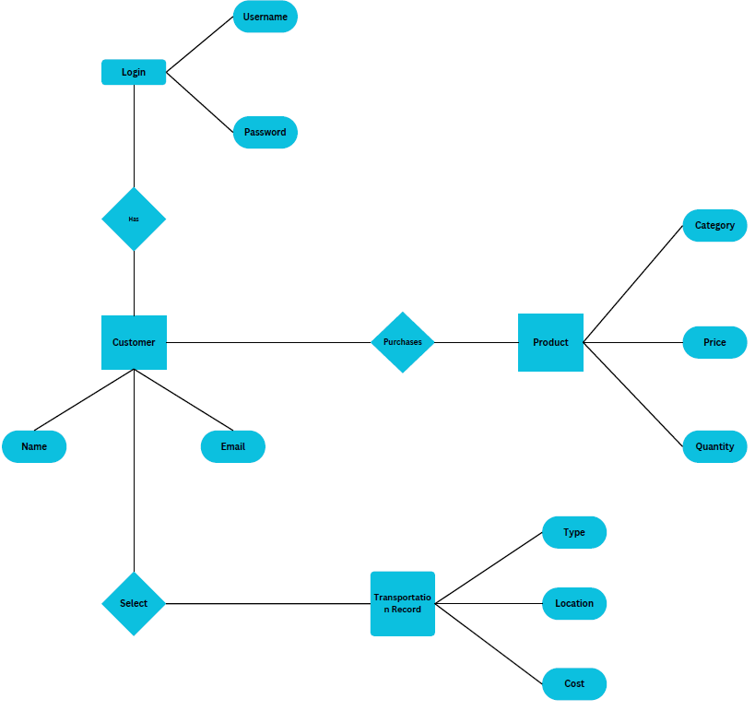
3.2 Data Flow Diagram (DFD)
DFD Level 0:
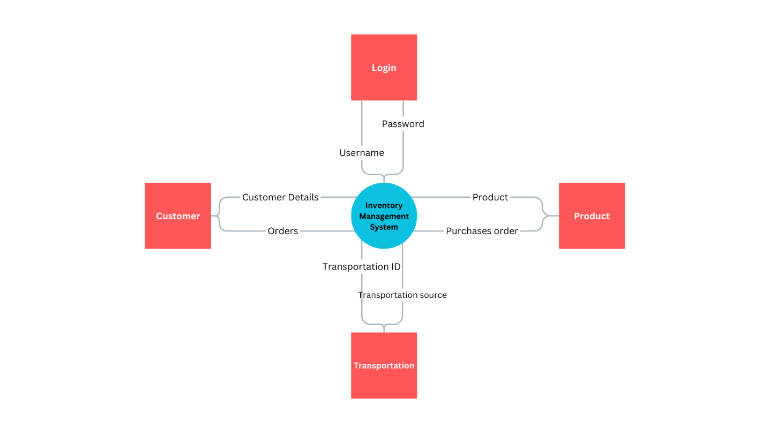
DFD Level 1:
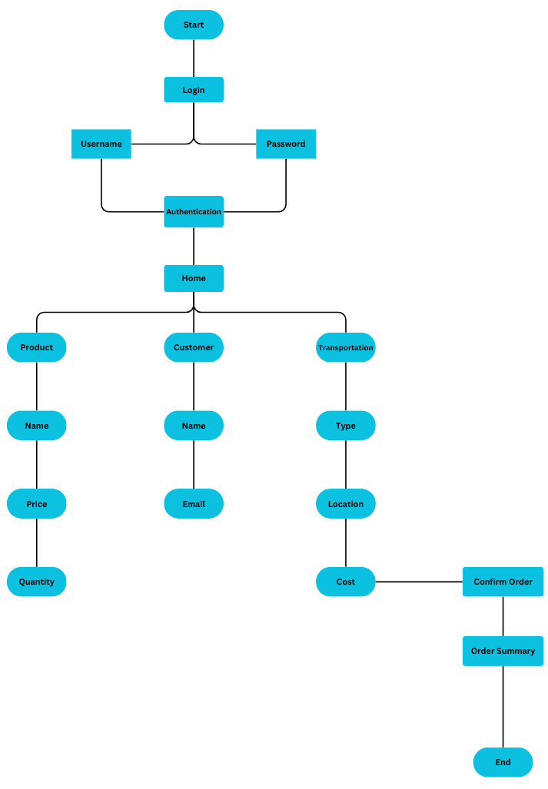
DFD Level 2:
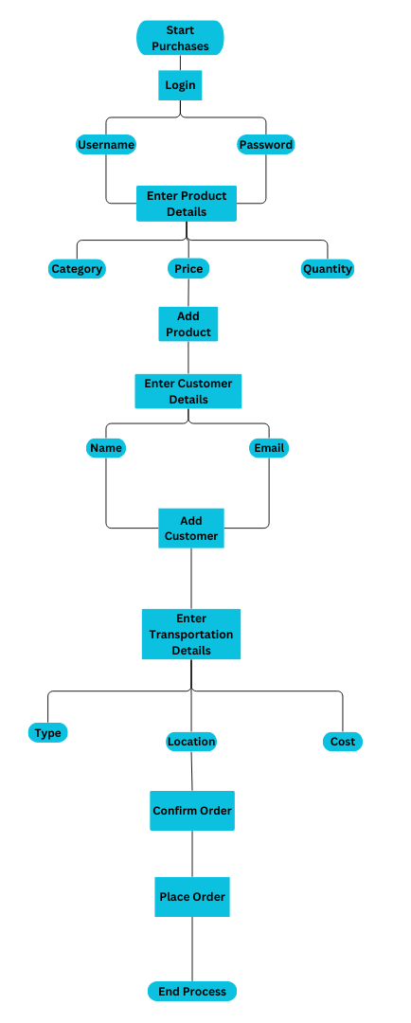

DATA DICTIONARY
Login Table
Column | Data Type | KEY
Username | VARCHAR (20)
Password | INT

Product Table
Column | Data Type | KEY
Product-ID | INT | Primary Key
Product-Name | VARCHAR (20)
Price | FLOAT

Customer Table
Column | Data Type | KEY
Customer-Name | VARCHAR (20) | Primary Key
Customer-Contact-Info | VARCHAR (50)

Transportation Table
Column | Data Type | KEY
Transportation-ID | INT | Primary Key
Transportation-Details | VARCHAR (50)
Transportation-Price | FLOAT

SCREENS

5.1 Input Screens:

**Login Page**
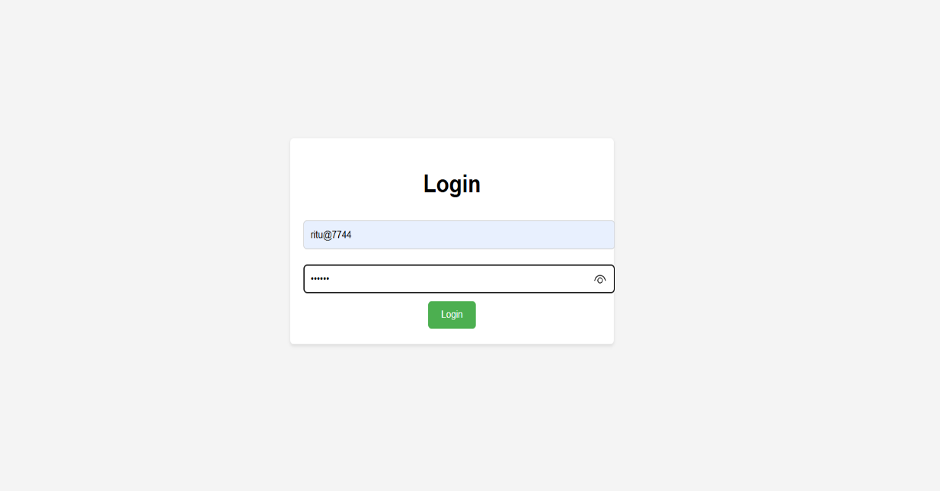
**Home Page**
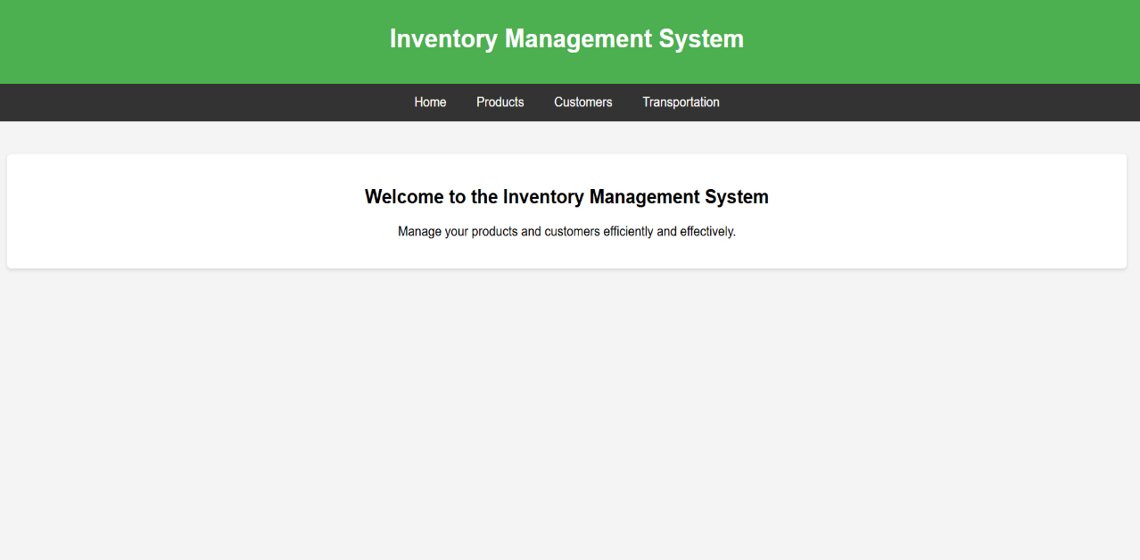

**Product Entry Page**

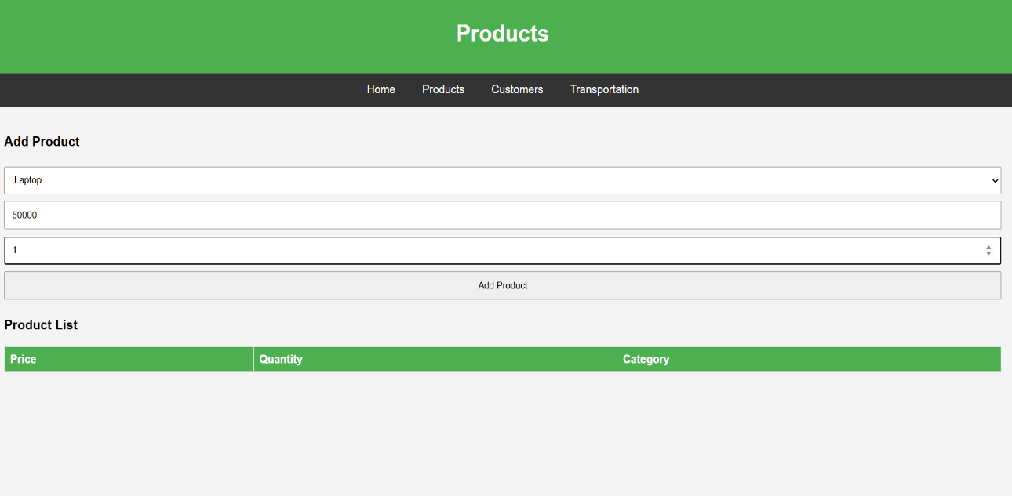

**Customer Management
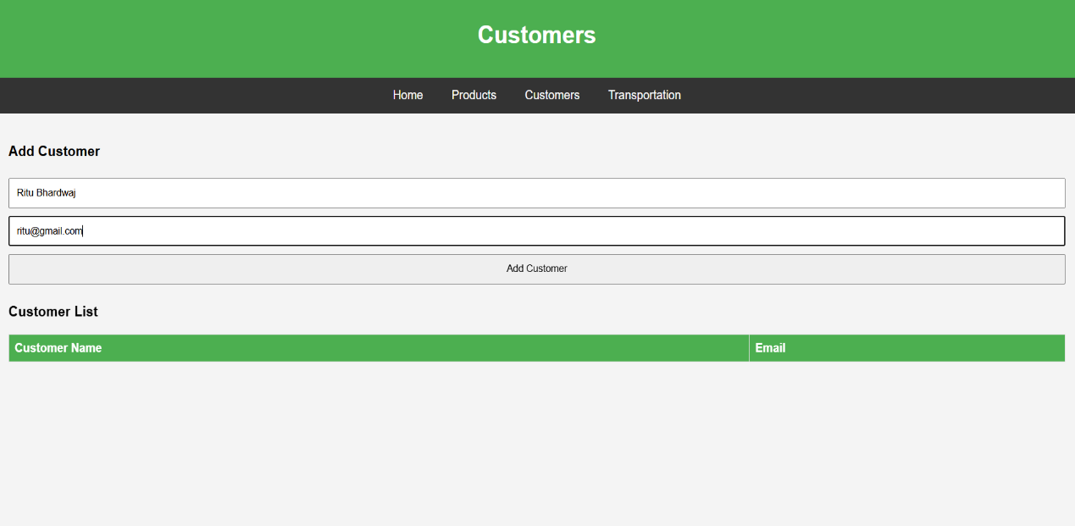

**Transportation Page**

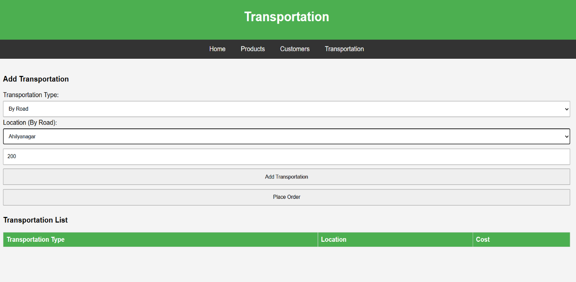

5.2 Output Screens:
**Product Details**
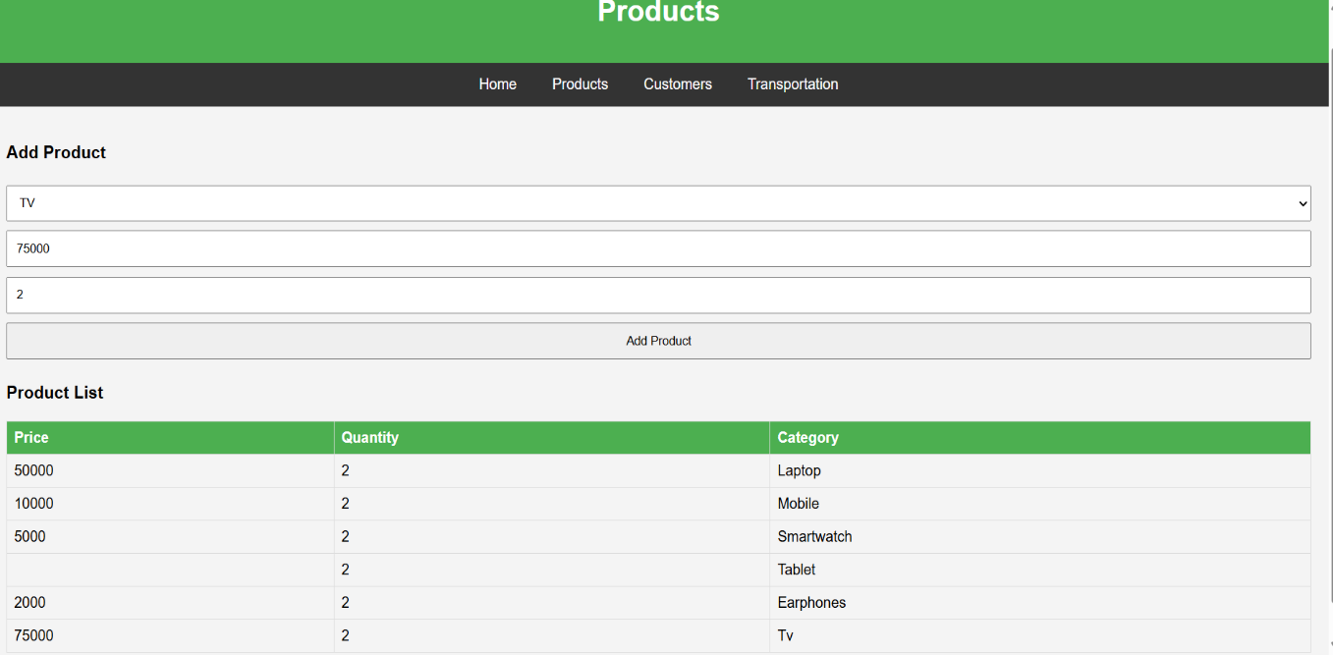

**Customer Details**

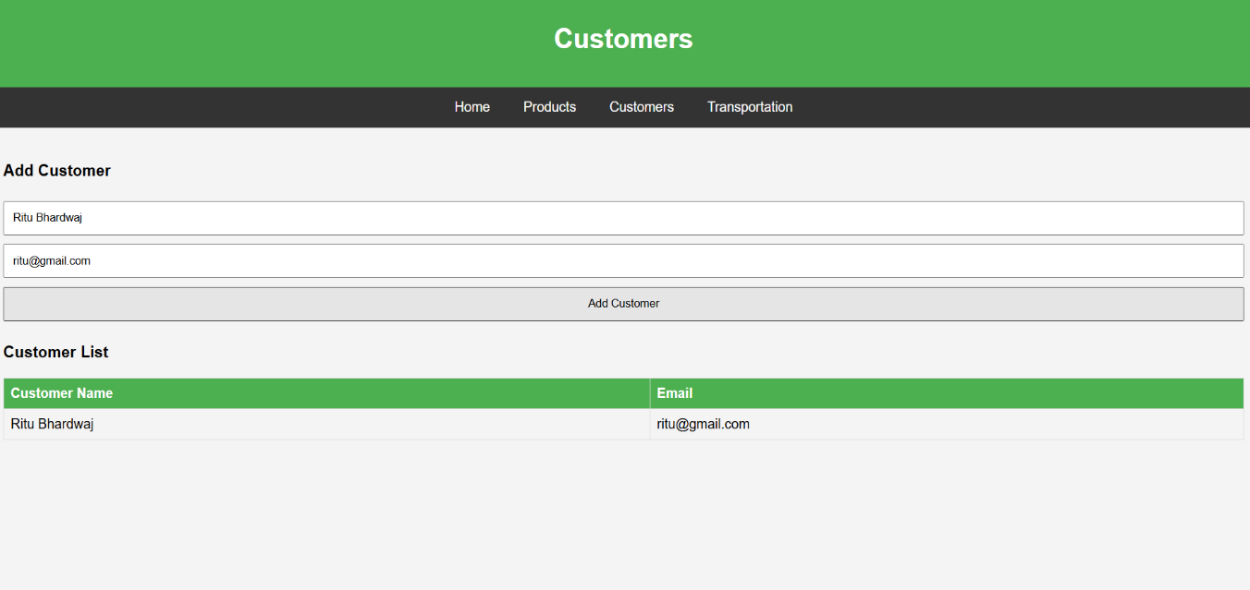

**Transportation Details**
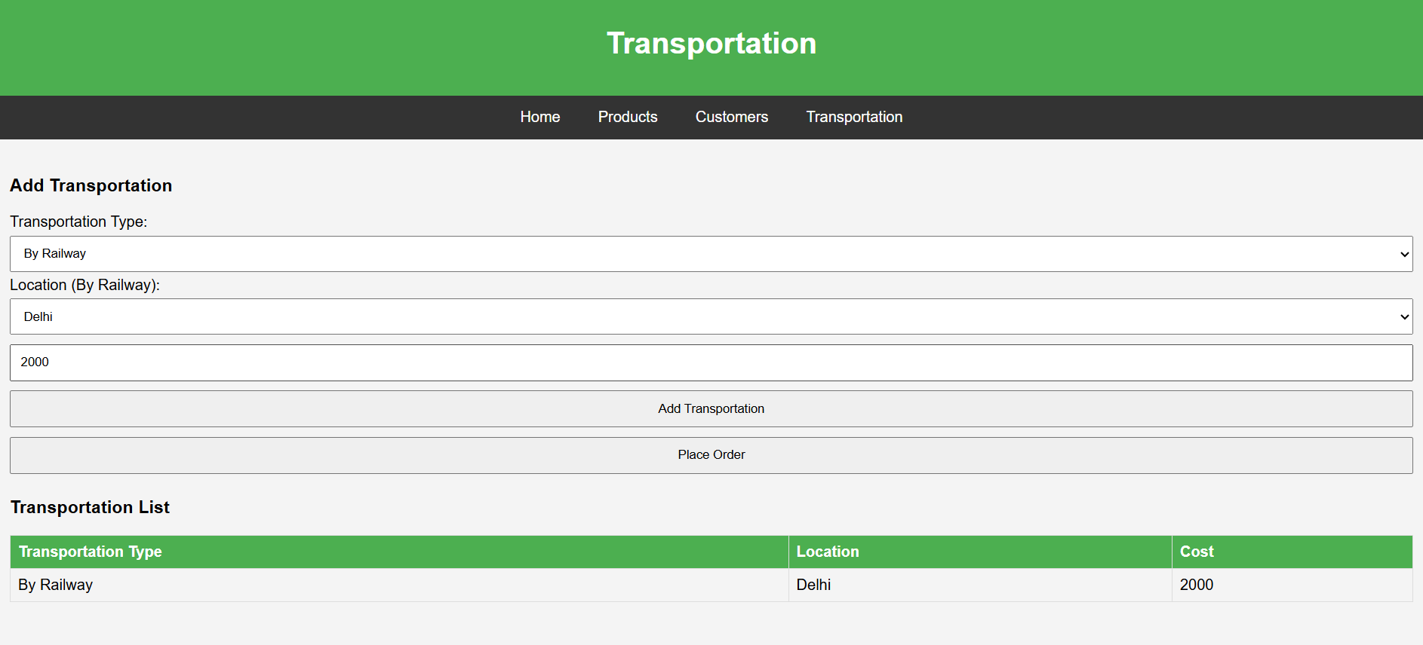
**Order Summary**
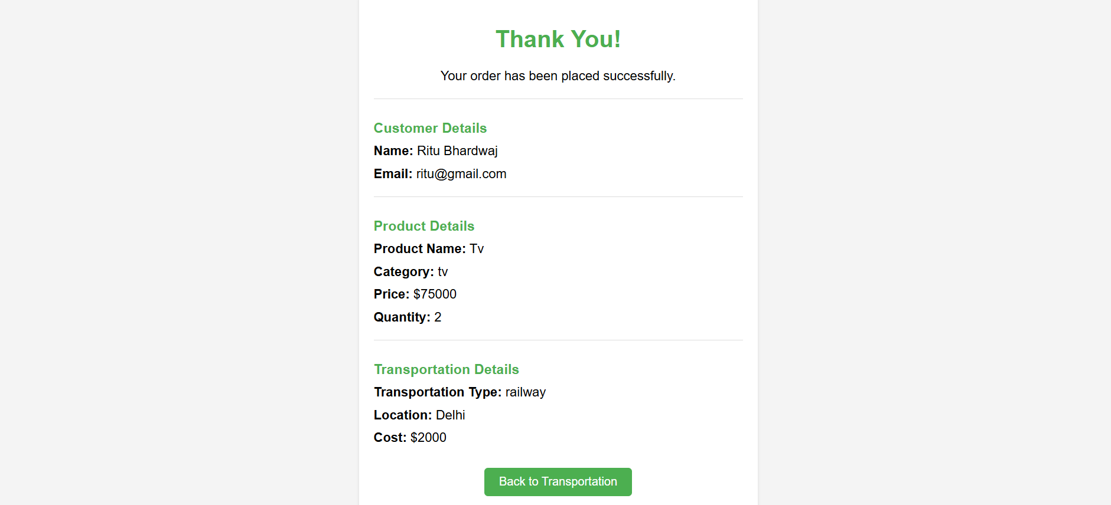

Test Case ID | Test Case Name | Description | Steps | Input | Expected Result | Actual Result | Status
TC01 | Login_Username_Check | Username must be in alphabetical format | 1. Enter alphabets in the username field. 2. Click "Login". | ABC | No error message should be displayed. | No error message displayed. | Pass
TC02 | Login_Username_Check | Username should not allow numbers/special characters | 1. Enter "ABC123" in the username field. 2. Click "Login". | ABC123 | Error message should appear. | Error message appeared. | Pass
TC03 | Login_Password_Check | Password should be masked while typing | 1. Enter password "12345". 2. Click "Login". | 12345 | Password should be hidden. | Password is hidden. | Pass
TC04 | Login_Password_Check | Password should not allow less than 5 characters | 1. Enter "123". 2. Click "Login". | 123 | Error message should appear. | Error message appeared. | Pass
TC05 | Login_Password_Check | Password should not accept only special characters | 1. Enter "@#$!". 2. Click "Login". | @#$! | Error message should appear. | Error message appeared. | Pass
TC06 | Navigation_Home | Clicking "Home" should navigate to home.html | 1. Click on "Home" in the navigation bar. | Click | Home page should open. | Home page opened. | Pass
TC07 | Navigation_Product | Clicking "Products" should navigate to product.html | 1. Click on "Products" in the navigation bar. | Click | Product page should open. | Product page opened. | Pass
TC08 | Transportation_Type | User should be able to select transportation type | 1. Open transportation.html. 2. Select "By Road". | Select | Dropdown should allow selection. | Selection allowed. | Pass
TC09 | Transportation_Cost | Selecting location should update cost field | 1. Select "Mumbai" under "By Railway". | Mumbai | Cost should be updated. | Cost updated to 1000. | Pass
TC10 | Place_Order | Clicking "Place Order" should redirect to thank you page | 1. Fill in transportation details. 2. Click "Place Order". | Click | Redirect to "Thank You" page. | Redirect successful. | Pass
Test Cases
LIMITATIONS AND FUTURE ENHANCEMENTS
7.1 Limitations
- Currently lacks mobile support.
- Limited real-time analytics.
7.2 Future Enhancements
- Develop a mobile application.
- Add AI-based inventory forecasting.
- Integrate with third-party logistics.

BIBLIOGRAPHY
- W3 Schools
- code school
- JavaTpoint
Thank You!

